adidas Sales Data Report

Executive Summary
This report analysis adidas Sales Data from Kaggle between for the years 2020 and 2021 to gain insights into sales operation. The primary objectives to assess total sales, total cost and revenue growth. The findings will assist the senior management in making informed strategic decision.

Scope
- Sales performance
- Retailer Insights
- Sales Trends
- Profitability

Data Specs
Here is the table which used to conduct our analysis:
Sales Adidas.

The Analysis

Sales Performance:
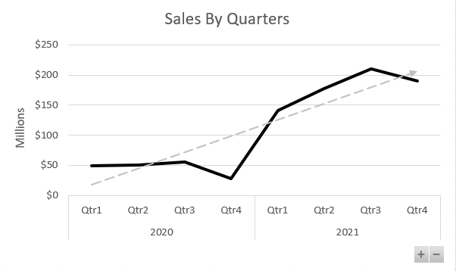
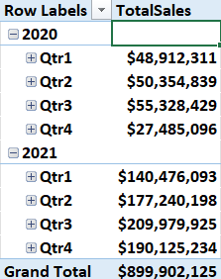
What are the total sales for each quarter?

Which the products have the highest and lowest sales?
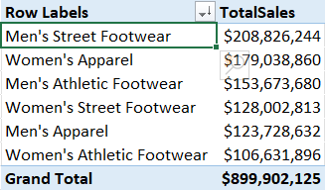
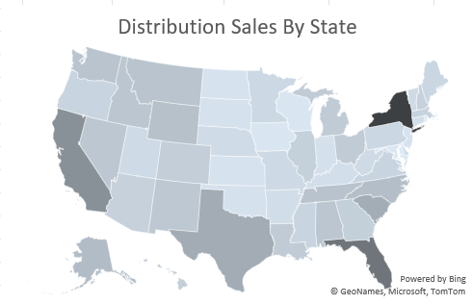
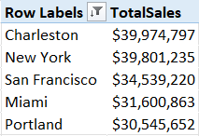
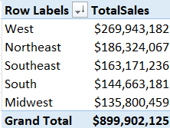
How do sales compare across different regions and states?

Retailer insights:
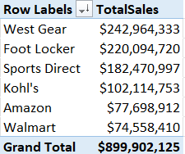
Which retailer has the highest and lowest sales?

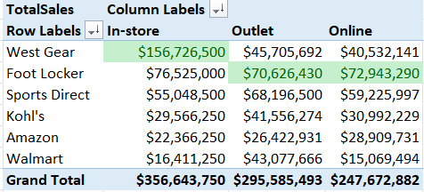
What is the highest sales method per retailer?

Sales Trends:

How have sales evolved over time?

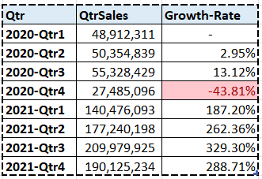
What is the growth rate of sales quarter-over-quarter?

Profitability:
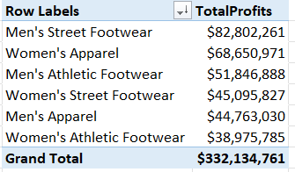
What is the profit margin for each product?
Which products are the most profitable?

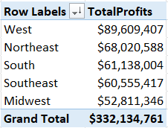
How does profitability vary by region?

